CS 499 Module One Assignment Template

Complete this template by replacing the bracketed text with the relevant information.

- Self-Introduction: Address all of the following questions to introduce yourself.

  - How long have you been in the Computer Science program?
I have been in the program since January 2024, so a little under 2 years, and I am on track to graduate next year (2026).

  - What have you learned while in the program? List three of the most important concepts or skills you have learned.
While in the program I’ve learned a lot, but it has also felt overwhelming at times because there are so many different languages and tools. Three of the most important skills/concepts I’ve learned are:
Object-oriented programming (OOP) in Python, Java, and C++ — classes, encapsulation, inheritance, and designing programs that can grow.
Full-stack / data-driven development — building a Python CRUD module to connect a dashboard to a MongoDB database (CS 340 Grazioso Salvare).
Software design and documentation — creating UML, system design, and requirements (CS 230/CS 255 style projects like DriverPass/The Gaming Room) so code is not just “working” but structured for other people.

  - Discuss the specific skills you aim to demonstrate through your enhancements to reach each of the course outcomes.
Through my enhancements I want to show that I can:
take an existing project and refactor it using solid software engineering practices (classes, separation of concerns, error handling);
improve performance of a program by choosing better data structures and algorithms;
secure and extend a database-backed application so that it looks like something a real organization (like Grazioso Salvare or Artemis Financial) could actually use; and
communicate what I did through code review, narratives, and a professional self-assessment.

  - How do the specific skills you will demonstrate align with your career plans related to your degree?
I want to go into software / application development (possibly mobile or full stack). Being able to show I can (1) read old code, (2) improve it, and (3) explain what I did is exactly what most entry-level software jobs want. The enhancements will let me show employers I can work with existing codebases — not just greenfield school projects.

  - How does this contribute to the specialization you are targeting for your career?
This contributes to my specialization by showing I can build data-driven applications that follow good design, use real database connections (MongoDB), and apply secure coding / defensive thinking. A lot of my SNHU work has been around CRUD, dashboards, and small utility apps, so I want my portfolio to show that I can grow those into production-style features.

- ePortfolio Set Up:

  - Submit a screen capture of your ePortfolio GitHub Pages home page that clearly shows your URL.
    - You already have a repository in GitHub where you uploaded projects in previous courses. Your ePortfolio will reside in GitHub but can link to work at other sites, such as Bitbucket. 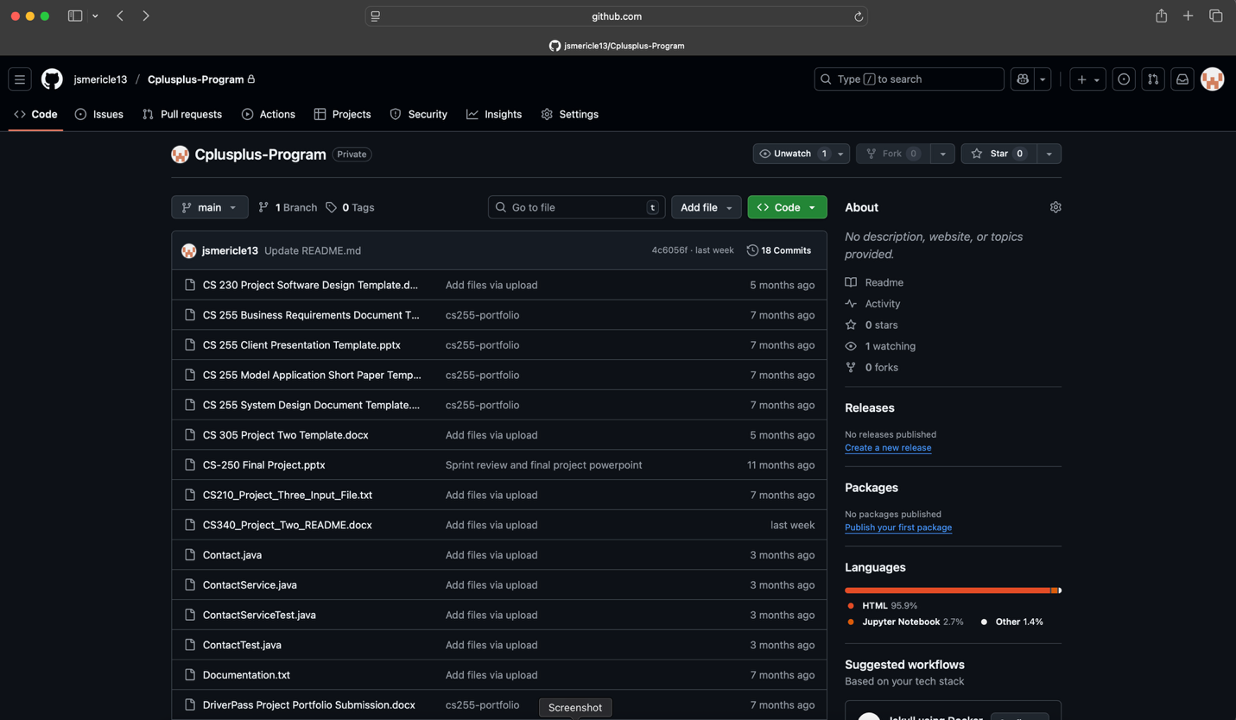

  - Use the GitHub Pages link in the Resource section for directions on:
    - How to create your GitHub website and publish code to GitHub Pages
    - Issues, such as adding links to other sites

  - Paste a screenshot of your GitHub Pages home page with your URL clearly showing in the space below.

[Paste the screenshot here of your GitHub Pages home page.]

- Enhancement Plan:

  - Category One: Software Engineering and Design
    - Select an artifact that is aligned with the software engineering and design category and explain its origin. Submit a file containing the code for the artifact you choose with your enhancement plan.

I will use my CS 230 / “Draw It or Lose It” (The Gaming Room) / DriverPass-style Java application and design documents as my software engineering artifact. The original assignment focused on requirements, UML, and recommending an architecture for a game/service with multiple clients. It aligns with this category because it is about designing and structuring software — not just coding.
ii. Practical plan for enhancement (with pseudocode)
Right now the design is mostly conceptual. My enhancement will be to turn the design into a cleaner, layered implementation:
Add a Controller/Service/Model separation so UI (or API) is not mixed with logic.
Add user/session management so more than one client can access it safely.
Add error and logging so a future dev can maintain it.
Clean up the class diagrams to match the actual code.
Note: Your artifact may be work from the following courses:

- IT 145: Foundation in Application Development
- CS 250: Software Development Lifecycle
- CS 260: Data Structures and Algorithms
- IT 315: Object Oriented Analysis and Design
- CS 320: Software Testing, Automation, and Quality Assurance
- CS 330: Computational Graphics and Visualization
- CS 340: Advanced Programming Concepts
- CS 350: Emerging Systems Architectures and Technologies
- CS 360: Mobile Architecture and Programming
- IT 365: Operating Environments
- IT 380: Cybersecurity and Information Assurance
- CS 405: Secure Coding
- CS 410: Reverse Software engineering
- IT 340: Network and Telecommunication Management
- IT 380: Cybersecurity and Information Assurance

    - Describe a practical, well-illustrated plan for enhancement in alignment with the category, including a pseudocode or flowchart that illustrates the planned enhancement.

- Create GameSession, Player, and Room model classes.
- Create a GameService class that handles business rules (create room, join room, start round).
- Create a simple REST-style or CLI controller to trigger service methods.
- Add basic validation (no duplicate player names, max players, etc.).
- Update UML/design doc to match the actual code structure
CLASS GameService
METHOD createRoom(roomName)
IF roomName exists THEN
RETURN error "Room exists"
ELSE
rooms.add(new Room(roomName))
RETURN success
END

METHOD joinRoom(roomName, playerName)
room = rooms.find(roomName)
IF room == null THEN RETURN error
IF room.hasPlayer(playerName) THEN RETURN error
room.addPlayer(new Player(playerName))
RETURN success
END

METHOD startGame(roomName)
room = rooms.find(roomName)
IF room.readyToStart() THEN
room.setStatus("ACTIVE")
ELSE
RETURN error "Not enough players"
END
END
END

CONTROLLER (main or API)
DISPLAY menu
WHILE user not exit
choice = getInput()
CALL GameService methods based on choice
DISPLAY result
END

For this category of enhancement, consider improving a piece of software, transferring a project into a different language, reverse engineering a piece of software for a different operating system, or expanding a project’s complexity. These are just recommendations. Consider being creative and proposing an alternative enhancement to your instructor.

Think about what additions to include to complete the enhancement criteria in this category. Since one example option is to port to a new language, that is the kind of scale that is expected. This does not mean you need to port to a new language but instead have an equivalent scale of enhancement. Underlying expectations of any enhancement include fixing errors, debugging, and cleaning up comments, but these are not enhancements themselves.

    - Explain how the planned enhancement will demonstrate specific skills and align with course outcomes.

      - Identify and describe the specific skills you will demonstrate that align with the course outcome.
Applying software design patterns / layered architecture.
Turning requirements + UML into working code.
Refactoring for maintainability and readability.
Adding basic security thinking (validation, not trusting input).
Documenting decisions so another developer can continue the project.

      - Select one or more of the course outcomes below that your enhancement will align with.

CO2: Design, develop, and deliver professional-quality communications… (updated UML, comments, README).
CO3: Design and evaluate computing solutions using CS practices (turning design into layered code).
CO4: Use well-founded techniques/tools to implement computing solutions.
(Optional) CO5: if I call out validation / input checking explicitly.

Course Outcomes:

- Employ strategies for building collaborative environments that enable diverse audiences to support organizational decision-making in the field of computer science.
- Design, develop, and deliver professional-quality oral, written, and visual communications that are coherent, technically sound, and appropriately adapted to specific audiences and contexts.
- Design and evaluate computing solutions that solve a given problem using algorithmic principles and computer science practices and standards appropriate to its solution while managing the trade-offs involved in design choices.
- Demonstrate an ability to use well-founded and innovative techniques, skills, and tools in computing practices for the purpose of implementing computer solutions that deliver value and accomplish industry-specific goals.
- Develop a security mindset that anticipates adversarial exploits in software architecture and designs to expose potential vulnerabilities, mitigate design flaws, and ensure privacy and enhanced security of data and resources.

  - Category Two: Algorithms and Data Structures

- Select an artifact that is aligned with the algorithms and data structures category and explain its origin. Submit a file containing the code for the artifact you choose with your enhancement plan. You may choose work from the courses listed under Category One.

I will use my CS 210 Project Three – Grocery-Tracking Program in C++. The original program read item frequencies from a file, stored them in a map, let the user look up items, print all frequencies, and show a histogram. This fits this category because it already used maps/dictionaries and file I/O, and it can be extended to use more efficient lookups / multiple data structures.

- Describe a practical, well-illustrated plan for enhancement in alignment with the category, including a pseudocode or flowchart that illustrates the planned enhancement.

The current version is fine for a small file, but it can be improved to show stronger data-structure choices.
For this category of enhancement, consider improving the efficiency of a project or expanding the complexity of the use of data structures and algorithms for your artifact. These are just recommendations. Consider being creative and proposing an alternative enhancement to your instructor. Note: You only need to choose one type of enhancement per category.

Think about what additions to include to complete the enhancement criteria in this category. Since one example option is to port to a new language, that is the kind of scale that is expected. Perhaps you might increase the efficiency and time complexity of an algorithm in an application and detail the logic of the increased time complexity. Remember, you do not need to port to a new language but instead have an equivalent scale of enhancement. Underlying expectations of any enhancement include fixing errors, debugging, and cleaning up comments, but these are not enhancements themselves.

- Explain how the planned enhancement will demonstrate specific skills and align with course outcomes.

  - Identify and describe the specific skills you will demonstrate to align with the course outcome.

    - Keep the existing std::map<string, int> for sorted display.
    - Add a hash-table–style structure (e.g., unordered_map) for O(1) lookups from the menu.
    - Add input normalization (lowercase, trim) so user input always matches items.
    - Add an item-category index (e.g., “produce”, “bakery”, “frozen”) using a map<string, vector<string>>.
    - Measure / describe the time complexity of each operation and include that in the narrative.
LOAD dataFile
DECLARE orderedFreq = MAP() // for sorted printing
DECLARE fastFreq = HASHMAP() // for O(1) lookup
FOR each line in dataFile
item = normalize(line.item)
orderedFreq[item] += 1
fastFreq[item] += 1
END

DISPLAY menu
WHILE choice != EXIT
IF choice == LOOKUP
item = normalize(userInput)
IF fastFreq.contains(item)
PRINT fastFreq[item]
ELSE
PRINT "Item not found"
ELSE IF choice == PRINT_ALL
FOR item, count IN orderedFreq (in order)
PRINT item, count
ELSE IF choice == PRINT_HISTOGRAM
FOR item, count IN orderedFreq
PRINT item + repeat("*", count)
END
END

Selecting the right data structure for the job (ordered vs. fast lookup).
Showing algorithmic reasoning and time complexity (O(1) vs O(log n)).
Working with file input → in-memory structures → user interface.
Refactoring code to be modular (separate load, display, search).

  - Select one or more of the course outcomes listed under Category One that your enhancement will align with.

CO3: Design and evaluate computing solutions that solve a given problem using algorithmic principles…
CO4: Use well-founded techniques/tools in computing practices…
CO2 (indirect): I can explain in the narrative why I picked map and unordered_map.

  - Category Three: Databases

    - Select an artifact that is aligned with the databases category and explain its origin. Submit a file containing the code for the artifact you choose with your enhancement plan. You may choose work from the courses listed under Category One.

I will use my CS 340 – Grazioso Salvare Python CRUD module that connects to the MongoDB aac database. This is clearly a database artifact because it authenticates to MongoDB, performs create/read/update/delete, and was used to support a dashboard.

    - Describe a practical, well-illustrated plan for enhancement in alignment with the category, including a pseudocode or flowchart that illustrates the planned enhancement.

I will enhance it to look more like a small service layer instead of just a collection of CRUD calls.
For this category of enhancement, consider adding more advanced concepts of MySQL, incorporating data mining, creating a MongoDB interface with HTML/JavaScript, or building a full stack with a different programming language for your artifact. These are just recommendations; consider being creative and proposing an alternative enhancement to your instructor. Note: You only need to choose one type of enhancement per category.

Think about what additions to include to complete the enhancement criteria in this category. Since one example option is to port to a new language, that is the kind of scale that is expected. Perhaps you might increase the efficiency and time complexity of an algorithm in an application and detail the logic of the increased time complexity. Remember, you do not need to port to a new language but instead have an equivalent scale of enhancement. Underlying expectations of any enhancement include fixing errors, debugging, and cleaning up comments, but these are not enhancements themselves.
    - Explain how the planned enhancement will demonstrate specific skills and align with course outcomes.

      - Identify and describe the specific skills you will demonstrate that align with the course outcome.

- Add input validation / try–except around all Mongo calls.
- Add role-based or user-type–based access (e.g., admin can delete, staff can only read/update).
- Add one or two MongoDB aggregation pipelines (e.g., count animals by intake condition, find animals ready for training).
- Expose the CRUD operations through a simple Flask (or FastAPI) endpoint, so the portfolio shows “database + API”.
- Document connection/security concerns (never hardcode credentials).

FUNCTION get_db(role):
client = connect_to_mongo()
db = client["aac"]
RETURN (db, role)

FUNCTION find_animals(filter, role):
(db, role) = get_db(role)
TRY:
results = db.animals.find(filter)
RETURN list(results)
EXCEPT:
RETURN error("DB read failed")

FUNCTION delete_animal(id, role):
IF role != "admin":
RETURN error("not authorized")
(db, role) = get_db(role)
TRY:
db.animals.delete_one({"_id": id})
RETURN success
EXCEPT:
RETURN error("delete failed")

FUNCTION aggregate_by_breed(role):
(db, role) = get_db(role)
PIPELINE = [
{"$group": {"_id": "$breed", "count": {"$sum": 1}}},
{"$sort": {"count": -1}}
]
RETURN list(db.animals.aggregate(PIPELINE))

Database programming with MongoDB (CRUD + aggregation).
Security mindset: do not allow everyone to delete data; validate user roles.
API enablement: turning database code into a service others could call.
Error handling and defensive coding.

      - Select one or more of the course outcomes listed under Category One that your enhancement will align with.

CO4: implement computing solutions that deliver value and accomplish industry goals.
CO5: develop a security mindset that anticipates exploits and mitigates design flaws.
CO2: if I document the API and how to use it.

- ePortfolio Overall Skill Set

  - Accurately describe the skill set to be illustrated by the ePortfolio overall.
    - Skills and outcomes planned to be illustrated in the code review

Ability to read legacy / earlier-course code and improve it.
Identifying design problems (tight coupling, no validation, no layers).
Mapping changes back to course outcomes (CO3, CO4, CO5).

    - Skills and outcomes planned to be illustrated in the narratives

Clear, professional written communication explaining what the artifact was, what I improved, and why (CO2).
Reflection on trade-offs (performance vs. readability, security vs. convenience).
Connecting enhancements to realistic employer needs (maintainability, API access, data integrity).

    - Skills and outcomes planned to be illustrated in the professional self-assessment

Showing growth across the program (from simple scripts to layered apps).
Identifying gaps (e.g., more practice with automated testing / CI).
Explaining how the portfolio supports my goal to work in software / app development.

